**Centre Name: ACE-HCMC-2-FPT.**

**Address: 391A Nam Kỳ Khởi Nghĩa, Võ Thị Sáu, District 3, Hồ Chí Minh City**

**ONLINE MOBILE RECHARGE WEBSITE**

**Design Document**

|  |  |  |
| --- | --- | --- |
| **Supervisor:** | Mr. Le Tuan Xuyen | |
| **Semester:** | 3 | |
| **Batch No:** | T1.220210.E1 | |
| **Group No:** | 1 | |
| **Order:** | **Full name** | **Roll No.** |
| 1. | Nguyen Gia Bao | Student1396926 |
| 2. | Le Viet Hai Duong | Student1373756 |
| 3. | Tran Nguyen Thanh Toan | Student1429538 |
| 4. | Vo Ho An | Student1429123 |
| 5. | Doan Van Loc | Student1415997 |

* **This is to certify that**

Mr. Nguyen Gia Bao

Mr. Le Viet Hai Duong

Mr. Tran Nguyen Thanh Toan

Mr. Vo Ho An

Mr. Doan Van Loc

**have successfully designed & developed:**

eProject: Online Mobile Recharge Website

* **Submitted by:**

Mr. Nguyen Gia Bao

**Date of issue:** 24/02/2024

**Authorized Signature:**

**Table of Contents**

REVIEW 1 4

I. Introduction 5

II. Synopsis: 5

III. Problem Definition: 6

IV. Customer's Requirement Specifications 7

1. Home Page: 7

a. Header – All Page for client will extend the header: 7

b. Body: 7

c. Footer – All Page for client will extend the Footer: 7

2. Login(Register) Page: 8

3. Product Page: 8

4. Product Detail Page: 8

5. Cart Page: 8

6. CheckOut Page: 8

7. Dashboard Page: 8

8. Authorize: 9

a. Admin Authorize: 9

b. The user Authorize: 9

c. The general user who is not the member of site Authorize: 10

9. Non-functional Requirement Specifications 10

V. System Requirement Specifications 11

1. Server requirements: 11

a. Hardware: 11

b. Software: 11

2. Development Software: 11

3. Technology: 12

1. TASK SHEET REVIEW 1 13

REVIEW 2 14

I. Architecture & Design of the Project 15

1. Presentation 15

2. Business Logic 15

3. Data Access 15

II. Algorithms – Data Flowchart 16

1. Symbol generates: 16

2. Main data flowchart for users 17

3. Login process (For admins and members) 18

4. Logout process (For admins and members) 18

III. Use Case Diagram 19

IV. Entity – Relationship Diagrams 20

TASK SHEET REVIEW 2 21

# Acknowledgment

Our group would like to express our sincere gratitude to all those who assisted us during the development of this project.

Firstly, we are deeply thankful to our instructor, Mr. Le Tuan Xuyen, whose suggestions and encouragement, helped us to overcome not only technological problems, but also psychological tension. Without him, our project would not be successfully completed.

Secondly, we are truly grateful to the Project Team at the Head Office, which has given us an excellent opportunity to have our knowledge and skill tested. We are most certain that the experience we gained from this project will facilitate our future career greatly.

Finally yet most importantly, we would also like to give a sincerely thank you to our team members and dear classmate for always supporting us openly and enthusiastically.

# 

# 

# 

# REVIEW 1

## Introduction

Welcome to [], your ultimate decision for a fast and hassle-free online mobile recharge. In today’s fast-paced world, we truly understand the importance of staying connected and the significant of keeping your mobile services available at all time. With our user-friendly platform, you can recharge your prepaid mobile and management your account effortlessly, all from the comfort of your home or on the go.

At [], we strive to provide you with a seamless and secure experience. Whether you're topping up your talk time, subscribing to special recharges, or activating value-added services like caller tunes and do not disturb, we've got you covered. Our platform is designed to cater to the diverse needs of our users, offering a wide range of recharge options and payment methods to suit your preferences.

With a user-centric approach, we prioritize convenience, reliability, and transparency in every transaction. Our intuitive interface makes it easy for you to navigate through the site, explore various recharge plans, and complete your transactions in just a few clicks.

At [], we're not just about transactions; we're about building relationships. We value your feedback and are committed to continuously improving our services to exceed your expectations. Whether you're a registered user enjoying exclusive benefits or a guest exploring our offerings, we welcome your reviews and will use them to further improve our services quality.

Experience the convenience of online mobile recharge like never before with [Website Name]. Join millions of satisfied users who trust us for their mobile recharge and bill payment needs. Stay connected, stay empowered, with [].

## Problem Definition:

In today's fast-paced world, mobile phones have become an indispensable part of our lives, serving as our primary means of communication, information, and entertainment. However, traditional methods of mobile recharge and bill payment often present challenges and inconveniences for users, including:

* **Time Constraints:** Traditional recharge methods, such as visiting physical stores or payment centers, often consume valuable time and effort, especially for individuals with busy schedules.
* **Limited Accessibility:** Not everyone has easy access to physical recharge outlets, particularly in remote or rural areas, leading to difficulties in maintaining uninterrupted mobile services.
* **Security Concerns:** Users may have concerns about the security of their financial transactions and personal information when using certain recharge platforms or payment methods.
* **Complexity of Options:** The plethora of recharge plans and options available in the market can be overwhelming for users, making it challenging to identify the most suitable plan for their needs.
* **Lack of Transparency:** Users may encounter hidden charges or unclear terms and conditions when recharging their mobile or paying their bills through certain platforms, leading to distrust and dissatisfaction.

The problem statement revolves around the need for a user-centric, secure, and efficient online platform that addresses these challenges and provides users with a seamless experience for mobile recharge and bill payment. This platform should prioritize convenience, accessibility, transparency, and security, empowering users to manage their mobile services with ease and confidence, regardless of their location or technical expertise.

窗体底端

## Customer's Requirement Specifications

A web-site incorporating all the information about the Online Recharge services is required with following functionality

1. ***Functional requirements***

**User Registration and Authentication:**

Users should be able to create accounts on the platform by providing essential details such as mobile number, email address, and password. The platform should support user authentication mechanisms to verify the identity of registered users during login attempts.

**Recharge and Bill Payment:**

Users should have the option to recharge their prepaid mobile phones by selecting from various recharge denominations and plans available on the platform. For postpaid users, the platform should allow them to view and pay their monthly bills by entering their account details and selecting a payment method. The platform should support multiple payment gateways and secure transaction processing to facilitate seamless and reliable recharge and bill payment transactions.

**Account Management:**

Registered users should be able to access and manage their accounts, including viewing transaction history, updating personal information, and modifying account settings. Users should have the option to subscribe to value-added services such as caller tunes, do not disturb (DND) activation, and other premium offerings directly from their accounts.

**Recharge Plan Customization:**

The platform should allow users to customize their recharge plans based on factors such as talk time, data volume, validity period, and special offers. Users should be able to compare and evaluate different recharge plans to make informed decisions that align with their communication needs and budget constraints.

**Transaction Tracking and History:**

Users should have access to a comprehensive transaction history that details their recharge and bill payment activities, including transaction timestamps, amounts, and payment statuses. The platform should provide users with real-time updates and notifications regarding the status of their recharge and bill payment transactions, ensuring transparency and accountability.

**Feedback and Support:**

The platform should feature a dedicated feedback mechanism that allows users to submit comments, suggestions, and complaints regarding their experience with the platform's services. Customer support channels, including live chat support, email assistance, and helpline numbers, should be readily accessible to users seeking assistance or resolution of issues.

**Admin Panel:**

The platform should include an administrative panel that allows authorized personnel to manage user accounts, monitor transaction activities, and generate reports on platform performance. Admin users should have the authority to configure system settings, update content, and enforce security policies to ensure the integrity and reliability of the platform.

**Guest User Access:**

Guest users should have limited access to platform functionalities, including browsing recharge plans, making one-time recharges, and providing feedback without the need for account registration.

1. ***Nonfunctional requirements***

**Performance:**

The platform should demonstrate high performance and responsiveness, with minimal latency during user interactions such as browsing recharge plans, processing payments, and accessing account information.

Response times for key functionalities should be within acceptable limits, even during peak usage periods, to ensure a smooth user experience.

**Scalability:**

The platform should be designed to scale horizontally and vertically to accommodate increasing user traffic and transaction volumes over time.

It should support seamless expansion of hardware resources, database capacity, and network bandwidth to maintain optimal performance and availability under varying load conditions.

**Reliability:**

The platform should be highly reliable and resilient, capable of maintaining uninterrupted service availability and data integrity under normal operating conditions and in the event of system failures or disruptions.

Redundancy measures, failover mechanisms, and automated backup procedures should be implemented to minimize service downtime and data loss risks.

**Security:**

The platform should adhere to industry best practices and regulatory standards for data security, privacy, and compliance, including encryption of sensitive information, secure transmission protocols, and protection against unauthorized access or malicious attacks.

User authentication mechanisms should be robust and multi-factor authentication options should be available to enhance account security and prevent unauthorized access.

**Usability:**

The platform should prioritize usability and accessibility, with a user-friendly interface, intuitive navigation flow, and clear visual cues to guide users through the recharge and bill payment processes.

Accessibility features should be incorporated to accommodate users with disabilities, ensuring equal access to platform functionalities and content.

**Compatibility:**

The platform should be compatible with a wide range of devices, operating systems, and web browsers to ensure seamless access and consistent user experience across different platforms and devices.

Compatibility testing should be conducted regularly to identify and address any compatibility issues or inconsistencies that may arise across different environments.

**Maintainability:**

The platform should be designed to support easy modification, extension and maintenance, allowing for efficient code management, version control, and system updates. Documentation and knowledge transfer processes should be in place to facilitate ongoing maintenance and support activities, enabling developers and administrators to understand and manage the system effectively.

**Performance Monitoring and Analytics:**

The platform should be able to track system performance metrics, user behavior patterns, and transaction trends in real-time. Performance monitoring tools should provide actionable insights and alerts to identify potential bottlenecks, optimize resource utilization, and proactively address performance issues before they impact user experience.

## System Requirement Specifications

The Guest accessing the website for the first time can register right away or just search for a product but lack service. When they want to actually buy a product and pay for it, they need to register to become a customer then all of the service will be available.

### Server requirements:

#### Hardware:

|  |  |
| --- | --- |
| Component | Requirement |
| CPU | Processor type:  Pentium III-compatible processor or faster  Processor speed:  Recommended: 1.0 GHz or faster |
| OS | All OS(Windows ,Linux ,Android ,Mac OS …) |
| Memory (RAM) | RAM:  Minimum: 1 GB  Recommended: 2 GB or more  Maximum: Operating system maximum |
| Hard Drive | Free space:  Minimum: 10 MB |

#### Software:

|  |  |
| --- | --- |
| Component | Requirement |
| Web Browser | IE 8.0 , Firefox 3.0,Chrome or Higher….. |

### Development Software:

Microsoft SQL Server Management Studio

Microsoft Visual Studio 2022

### Technology:

ASP.Net Core 7.0

Entity Framework Core 7.0

Bootstrap 5.0

## TASK SHEET REVIEW 1

|  |  |  |  |  |  |  |  |
| --- | --- | --- | --- | --- | --- | --- | --- |
| **Project Ref. No.:**  **eP/Advertisement** **Portal Management** **System/01** | | **Project Title:** | **Activity Plan** **Prepared** **By:** | **Date of Preparation of Activity Plan:** | | | |
| **Sr.No.** | **Task** | **Actual Start** **Date** | **Actual** **Days** | **Team** **Mate** **Names** | **Status** |
| 1 | Introduce | Online Mobile Recharge Website | NGUYEN GIA BAO | 20/02/2024 | 1 | NGUYEN GIA BAO | Completed |
| 2 | Problem Definition | 20/02/2024 | 1 | NGUYEN GIA BAO | Completed |
| 3 | Requirement & Non-functional requirement | 20/02/2024 | 1 | NGUYEN GIA BAO | Completed |
| 4 | Process Analyst & Task sheet review | 20/02/2024 | 1 | NGUYEN GIA BAO | Completed |

# 

# 

# 

# REVIEW 2

## Architecture & Design of the Project

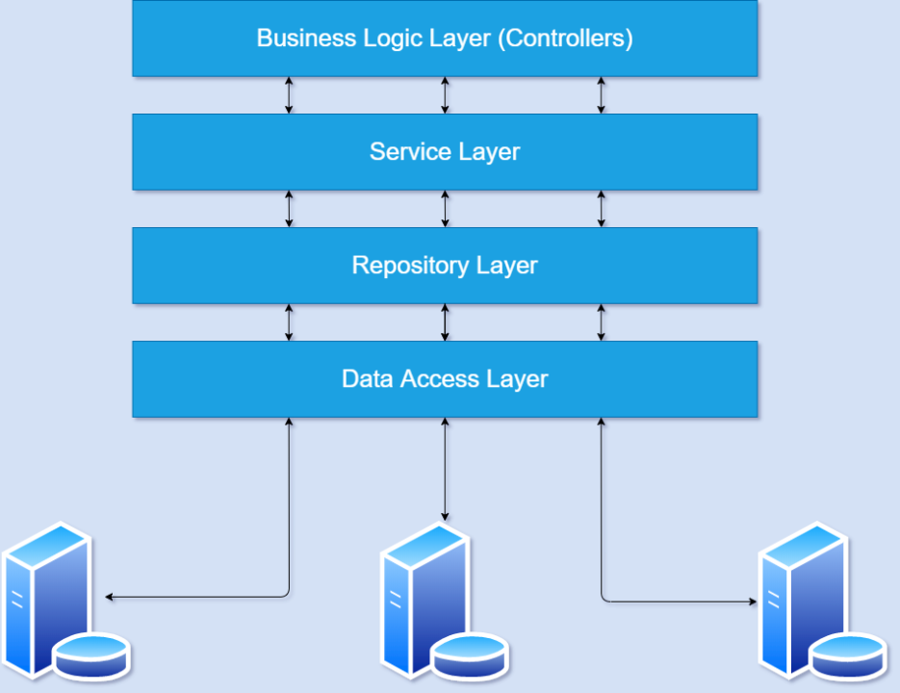

### Presentation

Exposes interaction capabilities for the end users or applications / systems wanting to interact with it.

Interacts with the Business Logic layer.

Can interact with other applications (through their presentation layers).

### Business Logic

Expresses domain knowledge, to be utilized from the Presentation layer.

Interacts with the Data Access layer.

Can interact with other applications (through their presentation layers).

### Data Access

Acts as a data persistence, to be utilized from Business Logic.

Can interact with other applications (through their presentation layers).

## Algorithms – Data Flowchart

### Symbol generates:

### Main data flowchart for users

### Login process (For admins and members)

### Logout process (For admins and members)

## Use Case Diagram

## Entity – Relationship Diagrams

# TASK SHEET REVIEW 2

|  |  |  |  |  |  |  |  |
| --- | --- | --- | --- | --- | --- | --- | --- |
| **Project Ref. No.:**  **eProject/Advertisement** **Portal Management** **System/01** | | **Project Title:** | **Activity Plan** **Prepared** **By:** | **Date of Preparation of Activity Plan:** | | | |
| **Sr.No.** | **Task** | **Actual Start** **Date** | **Actual** **Days** | **Team** **Mate** **Names** | **Status** |
| 1 | Architecture & Design of Project |  |  |  |  |  |  |
| 2 | Algorithms – Data Flowchart |  |  |  |  |
| 3 | Use Case Diagram & Task sheet review |  |  |  |  |
| 4 | Entity-Relationship Diagram |  |  |  |  |

|  |  |
| --- | --- |
| **Date:** | |
| **Signature of Instructor:** | **Signature of Team Leader:** |